Latest ISF website Update : 13/04/21

Home page:
- Modify the UVP with the following sentence: “Organising sport and educational events for school students between 13 and 18 years old”
- Add under “Sports” the same visual as in “about ISF” regarding ISF events being a mix of sport and education.

About ISF:
- Add a bloc in “about ISF” after ISF Vision regarding ISF values including a visual and link to UN SDG actions. Example of visual:
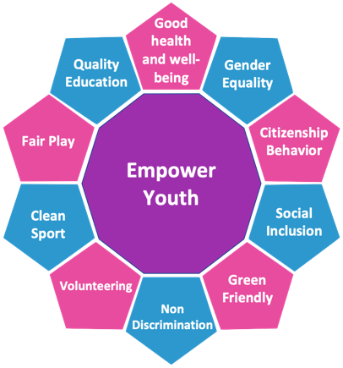

- Create a page dedicated to UN SDGs
- Create a page regarding Education accessible from the sport and education visual. (Text to be developed)
- Add a slider for ISF leaders under the President with Secretary general and 3 Vice-presidents (with name and title but no quote / Using the same layout and size)
- Create a page regarding ISF President with information (ISF President, IOC Olympic education commission member, ministerial advisor in France), vision and messages (Content to be developed)

Governance and Structure :
- Add continental bodies under general assembly with a different layout including a text (to be developed) and a link to a specific page regarding Continental bodies that will be created (this page will include a bloc for each of 4 continental bodies with Logo of the federation + President Name and photo + List of contacts + related articles
- Add a pop-up when clicking on EC members’ names that will show: Name + Title + country + short description or quote.

Events:
- Modify “Who can participate?” (Text to be developed)

